**JAVASCRIPT TERMWORK**

1. Write a program to Display all the prime numbers between 2 and 250.

<html>

<head>

<script type="text/javascript">

function calcPrimeNumber()

{

var beginNum = parseInt(document.numbers.firstNum.value);

var endNum = parseInt(document.numbers.secondNum.value);

var primeNumbs = new Array();

var ctr = beginNum;

while(ctr<=endNum)

{

if(isPrime(ctr)==true)

{

primeNumbs[primeNumbs.length] = ctr;

}

ctr = ctr+1;

}

if (primeNumbs.length == 0)

{

document.getElementById('output_content').innerHTML = "There were no prime no within the range.";

}

else

{

outputPrimeNums(primeNumbs);

}

}

function isPrime(num)

{

var flag = true;

for(var i=2; i<=Math.ceil(num/2); i++)

{

if((num%i)==0)

{

flag = false;

break;

}

}

return flag;

}

function outputPrimeNums(primes)

{

var html = "<h2>Prime Numbers</h2>";

for (i=0;i<primes.length;i++){

html += primes[i] + "<br/>";

}

document.getElementById('output_content').innerHTML = html;

}

</script>

</head>

<body>

<form name="numbers">

Beginning Number: <input type="text" name="firstNum" />

End Number: <input type="text" name="secondNum" />

<input type="button" value="Find Prime Numbers" onclick="calcPrimeNumber()" />

</form>

<div id="output_content">

</div>

</body>

</html>

**OUTPUT**

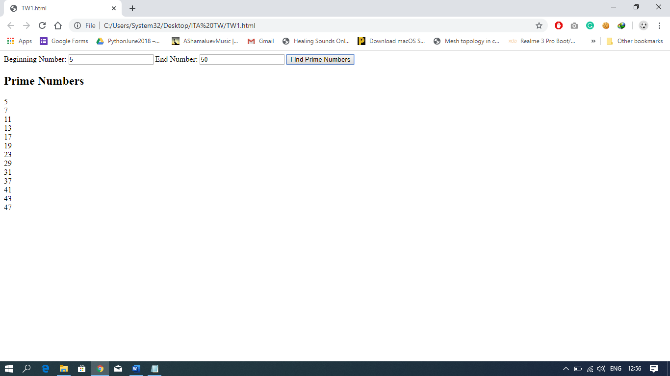

1. Write a Script to find the number of words, characters , vowels and consonant in a string taken as input from user.

<html>

<head>

<title> Termwork Question 2</title>

<script>

function give_count()

{

var str = document.words.inp1.value;

var characters = str.length;

var count_w = 0; var count_ch = 0; var count_con = 0; var count_vow = 0;

var vowels = (str.match(/[aeiou]/g)).length;

var words = (str.match(/\s/g)).length + 1;

var consonant = characters - vowels - words -1;

var print = "Counts are as follows:<br>No.of words : "+ words + "<br> No of characters : " +

characters + "<br>No of consonant : "+consonant +"<br> No of Vowels : "+vowels;

document.getElementById("answer").innerHTML = print;

}

</script>

</head>

<body>

<form name = "words">

Enter a string : <input type = "text" name = "inp1" />

<input type = "Button" value = "give_count" onclick="give_count()" />

</form>

<p id="answer"> </p>

</body>

</html>

**OUTPUT**

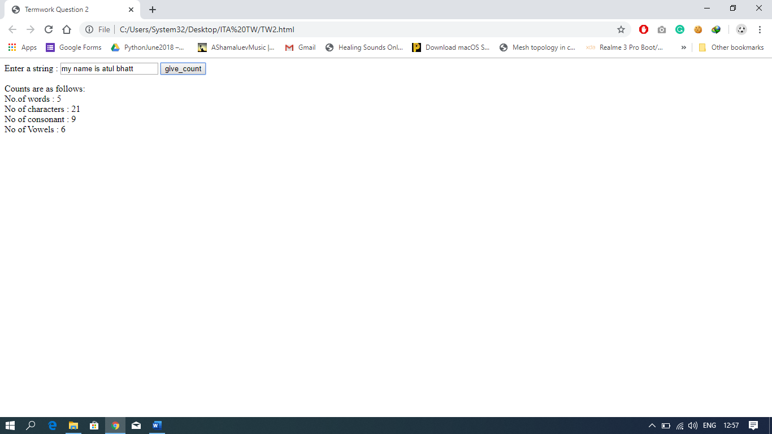

1. Design a web page to open a new window. The new window should contain test written on it. A confirm box should be displayed on new window to ask the user, whether user wants to close the window or not. If user press OK then close respective window.

**PART1**

<html>

<head>

<title>Termwork Question 3</title>

<script>

function open_new()

{

window.open("TW3.1.html");

}

</script>

</head>

<body>

<h1>Click the button to open a new page: </h1>

<input type = "button" value = "Click Me" name = "new_page" onclick = "open_new()">

</body>

</html>

**PART2**

<html>

<head>

<title> New Window</title>

</head>

<body>

<H1><center>TEST</center></H1>

<script>

var a = confirm("Do you want to close this window?");

if(a){

window.close();}

</script>

</body>

</html>

**OUTPUT**

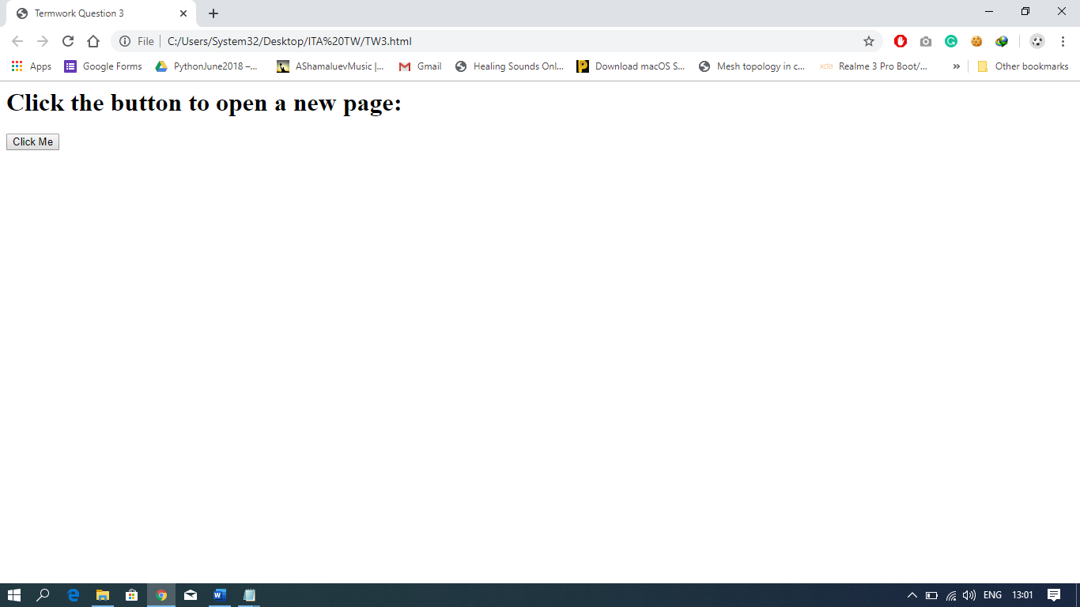

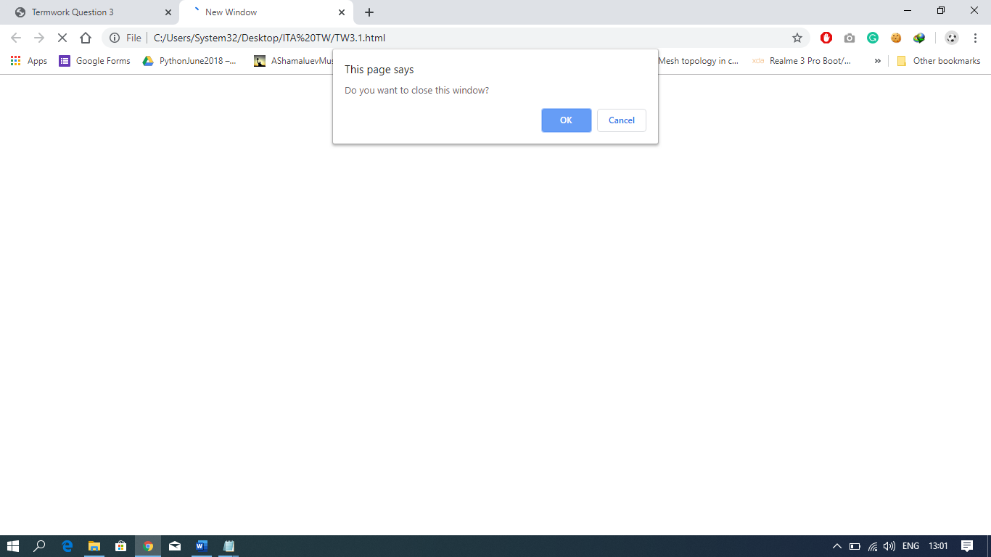

1. Design a webpage to take input from user and display the content on the webpage with Text color RED, background color YELLOW, size 24px. The rest of the text should not be changed within the paragraph.

<html>

<head>

<title>JavaSCript Question 4</title>

<script>

function magic()

{

var a = document.getElementById("content").value;

var b = document.getElementById("para");

b.innerHTML = a;

b.style.color = "red";

b.style.backgroundColor = "yellow";

b.style.fontSize = "24px";

}

</script>

</head>

<body>

<form>

Enter Text : <input type = "text" name = "content" id = "content">

<input type = "button" name = "action" value = "action" onClick = "magic()">

<br>

<p id = "para"> </p>

</form>

</body>

</html>

**OUTPUT**

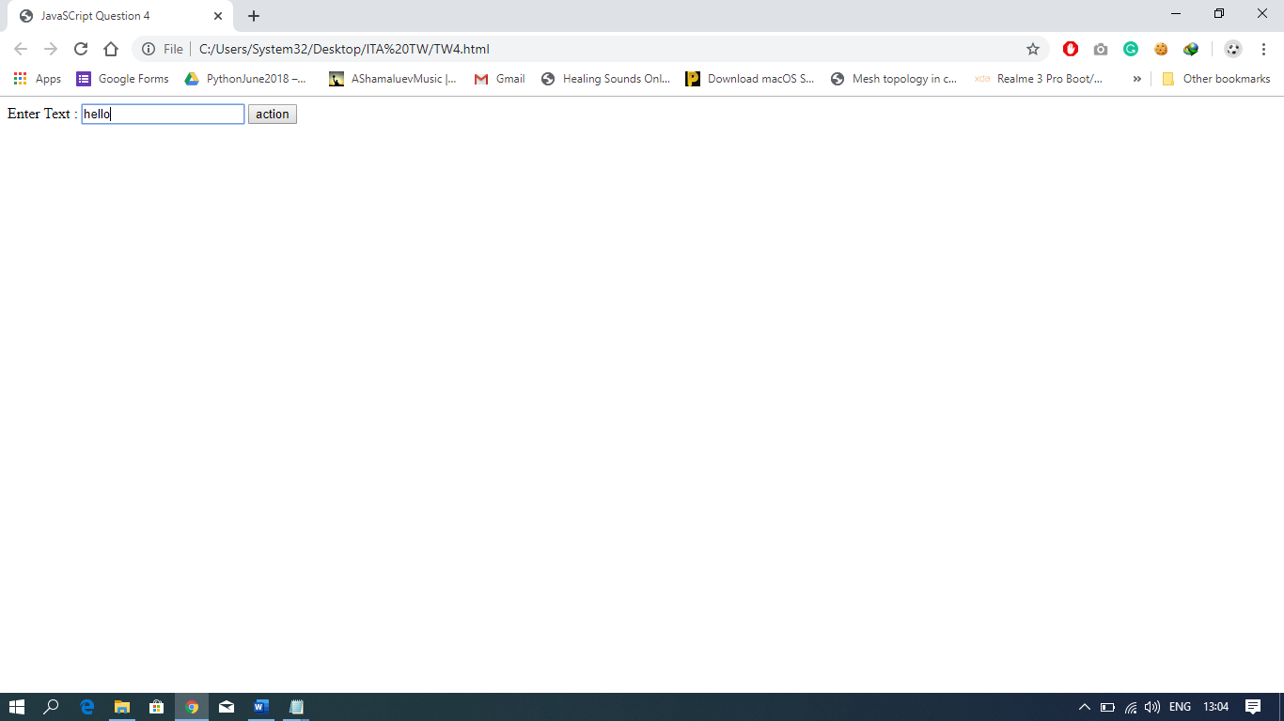

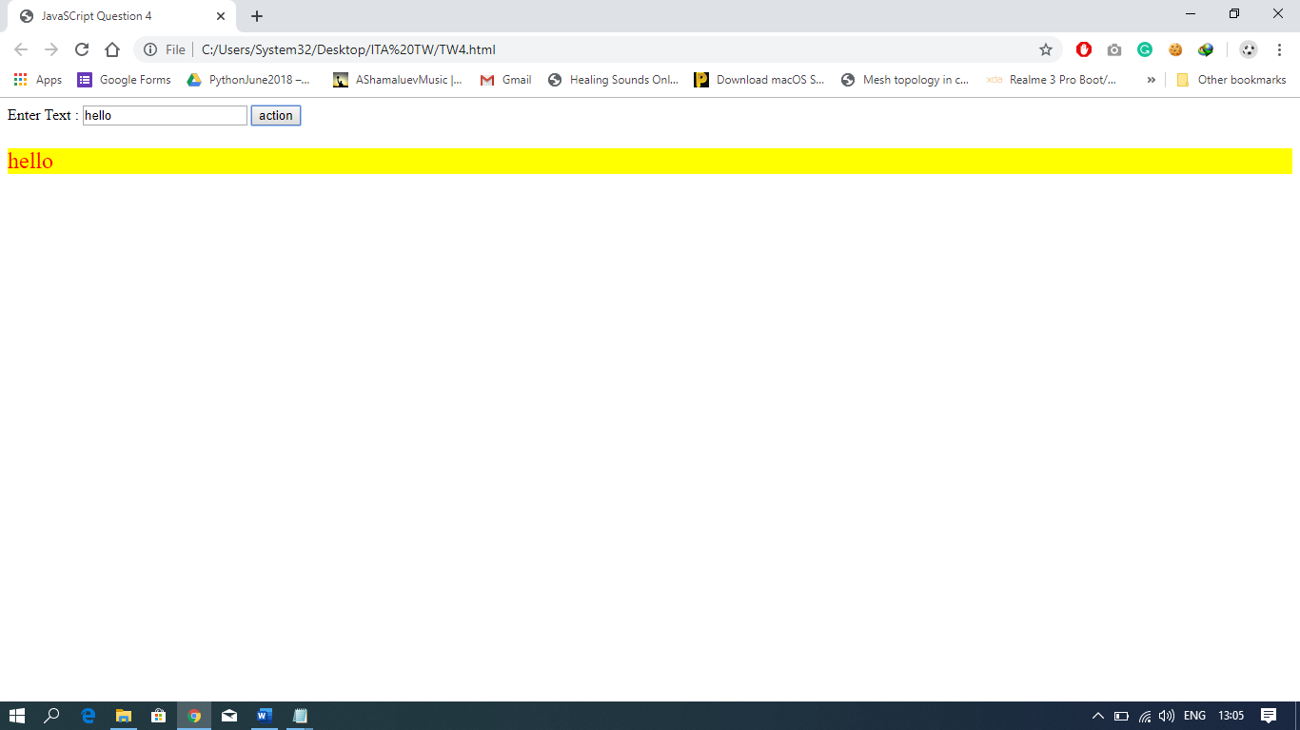

1. Design a registration form and using javascript provide the following validation:
2. No field should be left blank
3. Age should contain only numeric value.
4. Age should be greater than 18
5. Name should not contain any special character or numbers.

<html>

<head>

<title>Registration Form </title>

<script>

function validate()

{

var f = false;

var names = document.getElementById("names").value;

var age = document.getElementById("age").value;

var contact = document.getElementById("contact").value;

if(names.length == 0 || age.length == 0 || contact.length ==0)

{alert("One or more fields are empty!");

f = true;

}

else

{

if(!/^[0-9]+$/.test(age))

{alert("Please enter only numeric value for age.");

f = true;

}

else

{

if(parseInt(age)<=18)

{

alert("You should be greater than 18 to proceed further.");

f = true;

}

}

}

if(!f)

{

alert("Successful");

}

}

</script>

</head>

<body>

<h1> <center> Registration Form </center> </h1>

<form name ="register">

Name: <input type = "text" id = "names"><br><br>

Age : <input type= "text" id = "age"> <br><br>

Contact: <input type = "text" id = "contact"> <br><br>

<input type = "Button" value = "submit" onclick = "validate()">

</form>

</body>

</html>

**OUTPUT**

